Grazioso Salvare Dashboard
CS 340 – Client/Server Development, Project Two
Author: Tanvir Mahmod Bhuiyan

1. Project Overview
Grazioso Salvare is an international rescue-animal training organization that partners with a non-profit operating five animal shelters near Austin, Texas. This project delivers a full-stack web application that lets Grazioso Salvare staff search, filter, and visualize the Austin Animal Center Outcomes data set to identify dogs that are good candidates for search-and-rescue training. The system follows a Model-View-Controller (MVC) pattern: MongoDB is the Model, the Dash dashboard widgets are the View, and a custom CRUD Python module acts as the Controller that mediates between them.

2. Required Functionality
The dashboard implements every widget requested in the Dashboard Specifications Document:
- An unfiltered, interactive data table showing all records retrieved from MongoDB via the CRUD module's read() method.
- Interactive filtering controls (radio buttons) for Water Rescue, Mountain or Wilderness Rescue, Disaster or Individual Tracking, and Reset.
- A data table that dynamically re-populates based on the selected filter, with native sorting, per-column filtering, and pagination.
- A pie chart ("Preferred Animals by Breed") that updates to reflect whichever rows are currently visible in the data table.
- A geolocation chart (Leaflet map) that drops a marker on the selected animal's location and shows its breed and name in a popup.
- The Grazioso Salvare logo and a unique identifier (developer name) displayed on every screen of the dashboard.

2.1 Rescue-Type Filter Logic
The filtering logic follows the Rescue Type and Preferred Dog Breeds table supplied in the specifications document:
- Water Rescue: Labrador Retriever Mix, Chesapeake Bay Retriever, Newfoundland — Intact Female, 26–156 weeks old.
- Mountain or Wilderness Rescue: German Shepherd, Alaskan Malamute, Old English Sheepdog, Siberian Husky, Rottweiler — Intact Male, 26–156 weeks old.
- Disaster or Individual Tracking: Doberman Pinscher, German Shepherd, Golden Retriever, Bloodhound, Rottweiler — Intact Male, 20–300 weeks old.

2.2 Proof of Functionality — Screenshots
The five screenshots below were captured while testing the deployed dashboard and demonstrate each required state.
Screenshot 1 — Starting state (unfiltered data table, chart, and map):
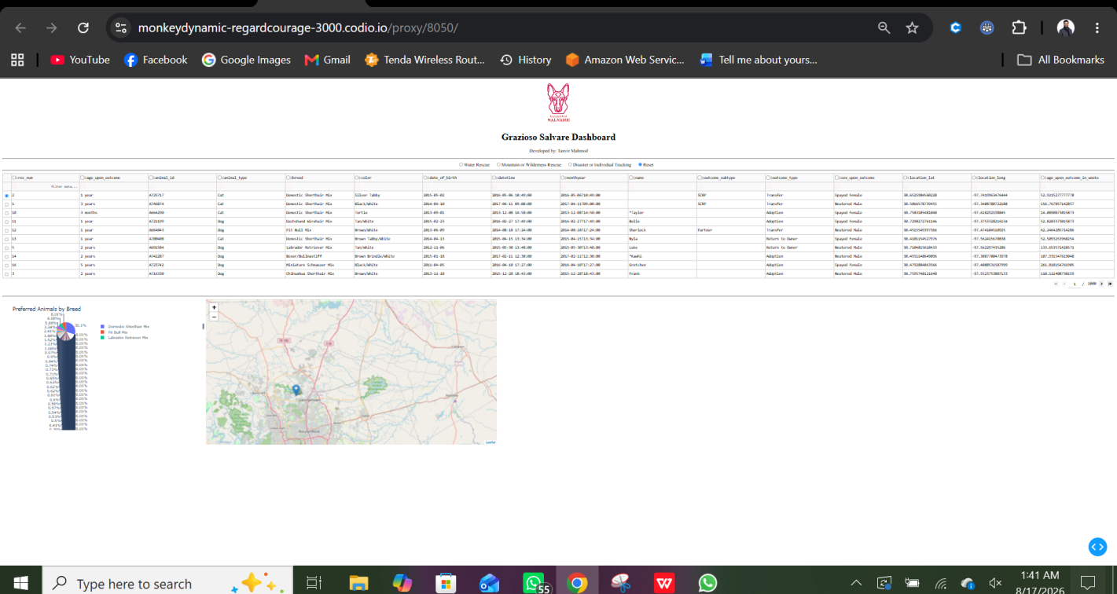
Screenshot 1 of 5 — Unfiltered starting state
Screenshot 2 — Water Rescue filter applied:
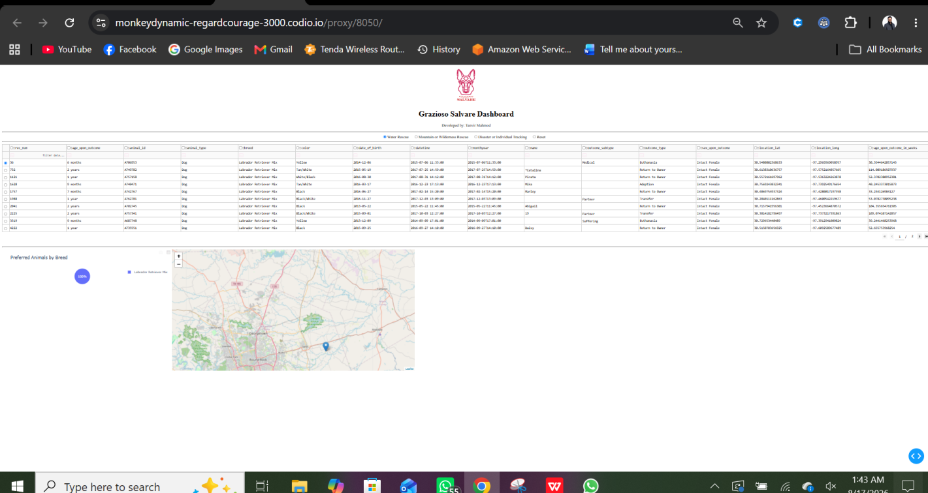
Screenshot 2 of 5 — Water Rescue filter
Screenshot 3 — Mountain or Wilderness Rescue filter applied:
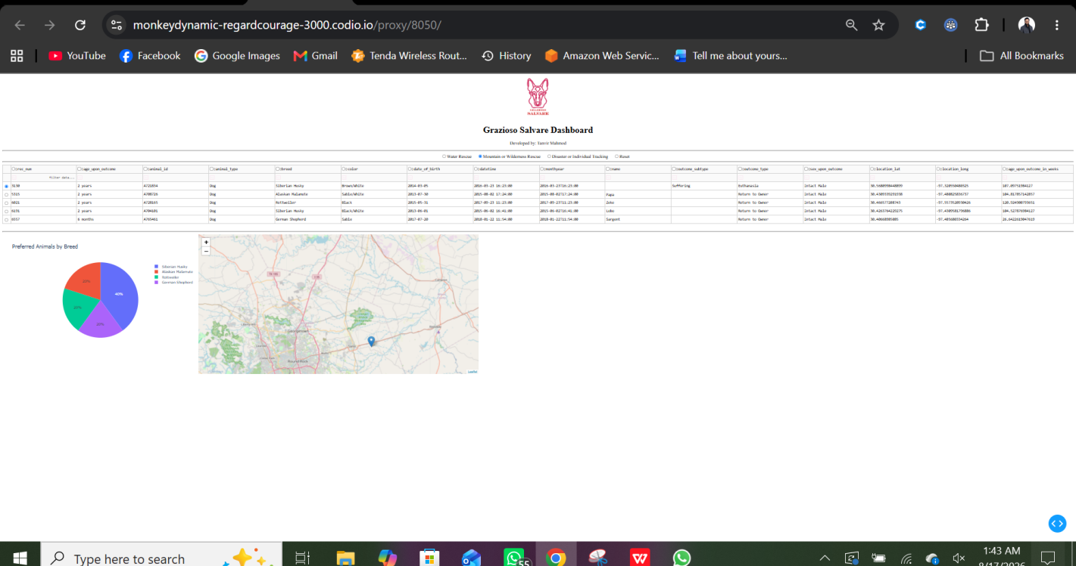
Screenshot 3 of 5 — Mountain or Wilderness Rescue filter
Screenshot 4 — Disaster or Individual Tracking filter applied:
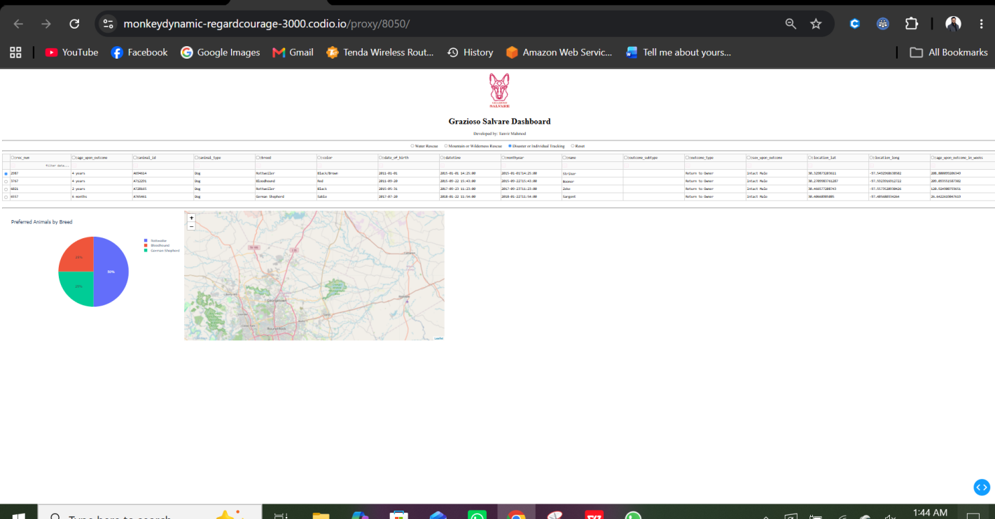
Screenshot 4 of 5 — Disaster or Individual Tracking filter
Screenshot 5 — Reset (returns to the unfiltered state):
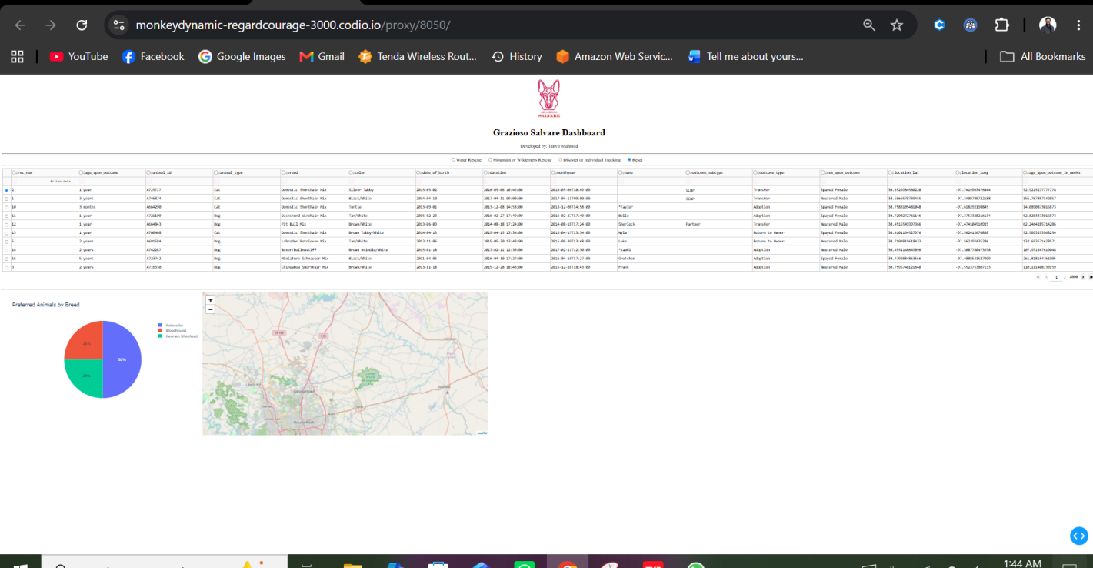
Screenshot 5 of 5 — Reset

3. Tools Used and Rationale

3.1 MongoDB (Model)
MongoDB was used as the model / data-persistence layer because the Austin Animal Center Outcomes data set is semi-structured — records vary in which fields are populated (for example, not every animal has a name or outcome subtype). MongoDB's document (BSON/JSON) model stores each animal record as a flexible document without requiring a rigid, pre-defined relational schema, so the collection can absorb missing or inconsistent fields without failed inserts. MongoDB also integrates cleanly with Python through the PyMongo driver, which maps naturally onto Python dictionaries and lists, making it straightforward to expose Create, Read, Update, and Delete (CRUD) operations to the rest of the application. Query performance on the filtering used in this dashboard (breed, sex, and age range) is efficient with MongoDB's native query operators such as $in and $gte/$lte.

3.2 Dash / Plotly (View and Controller)
The Dash framework (built on Flask, React, and Plotly.js) provides the View and Controller layers of the application. Dash lets the dashboard be written entirely in Python, avoiding the need to hand-write separate HTML, CSS, and JavaScript for the client. The View is defined declaratively through Dash's HTML and Core Components (dash_table.DataTable, dcc.RadioItems, dcc.Graph) inside app.layout. The Controller is implemented through Dash's @app.callback decorators, which wire component inputs (for example, the selected radio button) to outputs (the data table, chart, and map), automatically re-rendering only the affected widgets whenever the user interacts with a control. This reactive callback model is what allows the filtering options to drive the data table, chart, and geolocation map without any manual page reloads.

3.3 dash-leaflet
dash-leaflet wraps the Leaflet.js mapping library for Dash and was used to build the geolocation chart. It was chosen because it renders an interactive, pannable/zoomable map with marker, tooltip, and popup support directly from Python callbacks, and it does not require an external API key (unlike some commercial mapping services), which keeps the project free to run and easy to reproduce.

3.4 Jupyter / JupyterDash
JupyterDash was used so the entire dashboard could be developed, tested, and demonstrated inside the Codio Jupyter Lab environment provided for this course, without needing a separate production web server for grading and demonstration purposes.

4. Steps Taken to Complete the Project
- Reviewed the Dashboard Specifications Document and the Rescue Type and Preferred Dog Breeds table to understand the required widgets and filter logic.
- Reused and finalized the AnimalShelter CRUD Python module from Project One, exposing create(), read(), update(), and delete() methods backed by PyMongo.
- Connected the CRUD module to MongoDB using the aacuser account, and loaded the ProjectTwoDashboard.ipynb starter notebook.
- Built the unfiltered data table using db.read({}) to confirm the CRUD module and MongoDB connection worked end-to-end.
- Implemented three query helper functions (water_rescue_query, mountain_wilderness_query, disaster_tracking_query) that translate the Rescue Type and Preferred Dog Breeds table into MongoDB filter documents.
- Added dcc.RadioItems as the interactive filtering control and wired it to the data table through an @app.callback.
- Enabled native sorting, per-column filtering, and pagination on the DataTable, and added row/column selection for usability.
- Added a pie chart and a Leaflet map, both driven by callbacks that read the data table's derived_virtual_data / derived_virtual_selected_rows so they stay in sync with whatever the user is currently viewing.
- Added the Grazioso Salvare logo (base64-encoded) and a developer identifier to the layout.
- Deployed and tested the dashboard inside Codio, exercising all four filters plus Reset, and captured the five required screenshots.

5. Challenges Encountered and How They Were Overcome
MongoDB authentication failures (OperationFailure): The aacuser account referenced by the CRUD module had not actually been created in the MongoDB instance, and the connection string's authSource did not match the database the user account belonged to. This was diagnosed by connecting with mongosh directly and running db.getUsers(), which returned an empty list, confirming the account did not exist. It was resolved by creating the account with db.createUser() and correcting the authSource parameter in the MongoClient connection string to match the database ("AAC"/"aac") that owns the user.
Database name case sensitivity: MongoDB database names are case-sensitive, and the imported data set lived in a database named aac (lowercase), while the CRUD module was configured to use AAC (uppercase). Because MongoDB does not allow two databases whose names differ only by case, later commands failed with "db already exists with different case." This was resolved by running show dbs in mongosh to find the actual database name and updating the DB constant in the CRUD module to match it exactly.
Kernel appeared to hang with no error message: Early on, the connection cell would run indefinitely with no error and no output. Adding an explicit serverSelectionTimeoutMS to the MongoClient constructor, along with a client.admin.command('ping') call immediately after connecting, converted the silent hang into a fast, descriptive exception, which made the underlying authentication and host/port problems visible and fixable.
Cells executed out of order after a kernel restart: After restarting the kernel to pick up code changes, running only the last cell produced a NameError because earlier cells that defined app, db, and df had not been re-executed in the new kernel session. This was resolved by using Kernel > Restart Kernel and Run All Cells so every cell executes in the correct order from a clean state.
Empty data table after a successful connection: Once MongoDB authentication succeeded, the data table still showed no rows. Using mongosh to run show collections and db.animals.countDocuments() revealed the animals collection had never been populated. Running mongoimport with the provided aac_shelter_outcomes.csv file against the correct database and collection name loaded all 10,000 records and resolved the issue.

6. Resources and Links
- MongoDB Documentation — https://www.mongodb.com/docs/
- PyMongo Driver Documentation — https://pymongo.readthedocs.io/
- Dash by Plotly Documentation — https://dash.plotly.com/
- Dash Core Components — https://dash.plotly.com/dash-core-components
- dash-leaflet Documentation — https://www.dash-leaflet.com/
- JupyterDash (GitHub) — https://github.com/plotly/jupyter-dash
- Austin Animal Center. (2020). Austin Animal Center Outcomes [Data set]. City of Austin, Texas Open Data Portal. https://doi.org/10.26000/025.000001

